**SMART HELMET**:

SAFETY HELMET BASED ON THE SPEED

AND ALCOHOL CONTENT OF THE DRIVER

GROUP 3

**CONTENTS**:

1. BRIEF IDEA ABOUT THE PROJECT

2. METHODOLOGY

3. DESIGN PART AND BUSINESS DETAILS

4. INNOVATIVENESS OF THE PROJECT

5. HOW ARE WE GOING TO EXECUTE

5. TIMELINE AND OUR REQUIREMENTS

6. FUTURE WORK AND BUSINESS DETAILS

7. REFERENCES

PROJECT BRIEF

Nowadays the numbers of road accidents are increasing at a fast rate. In every minute, 17 persons are killed due to road accidents. And a major part of these road accidents occur due to over speeding and drunk driving. The major victims to the road accidents are the two wheeler drivers because since they are driving an open vehicle there is no protection of any kind for them. Hence we have decided to build a SMART HELMET for the safety of the bikers. This helmet warns the driver if he is drunk and over speeding. And still the biker does not agree to its warnings then it automatically switches off the ignition tank.

METHODOLOGY:

Smart Helmet works on the basic principles of sensors and IoT devices. It’s the integration of all such devices which makes it unique and efficient. It has sensors like:

1. **Gas Sensor**- Based on the concentration of the gas the sensor produces a corresponding potential difference by changing the resistance of the material inside the sensor, which can be measured as output voltage. Based on this voltage value the type and concentration of the gas can be estimated.
2. **Hall Sensor**- Works on the principle of magnets, Hall Voltage and Hall Current.

Apart from these sensors there are IoT devices like:

1. **Wireless Transciever**- A wireless transceiver consists of a transmitter and a receiver. In the transmitter, a process known as modulation converts electrical digital signals inside a computer into either RF or light, which are analog signals. Amplifiers then increase the magnitude of the signals prior to departing an antenna. At the destination, a receiver detects the relatively weak signals and demodulates them into data types applicable to the destination computer.

Rest all devices like Arduino we know how they work.

DESIGN PART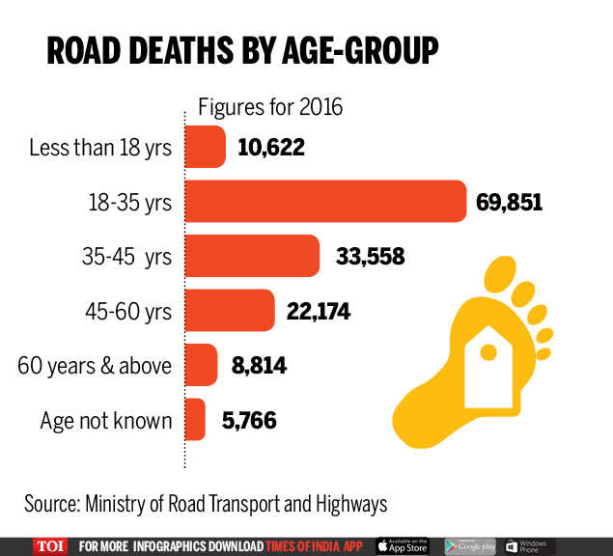:

Components of the project:

1. Speed sensor
2. Gas Sensor
3. Arduino
4. Motors
5. Wireless Transceivers
6. Battery

There are total 4 circuits in our system:

1. Alcohol Detection Circuit
2. Speed Detecting Circuit
3. Main Controlling Circuit
4. Action Circuit

OVERALL WORKING OF THE CIRCUIT:

So these four circuits work in unison for our smart helmet to work. The Alcohol Detection Circuit after detecting alcohol content in the driver’s breath sends signals to the Main Controlling Circuit so does the Speed Detecting Circuit. The Main Controlling Circuit after receiving all the signals takes appropriate action as per the code uploaded and sends signal to the Action Circuit located at the automobile’s fuel tank.

The Speed sensor detects the speed of the vehicle and the gas sensor detects whether the person is drunk or not. If the person is drunk (>=0.8BAC) and is exceeding the speed of 30km/hr then the buzzer would start ringing indicating the driver to stop the vehicle but still if the driver does not do so then the Main Circuit would give directions to the Ignition Control Circuit to turn off the fuel supply. Similarly if a non drunk person is exceeding the speed of 60 km/hr then the same process would repeat again.

**BUSINESS DETAILS-**

Our main target customers would be all the two wheeler drivers and also for drunk drivers. Since our HELMET gives a warning before actually coming into action, it would be in great demand as there is no strict stopping of the vehicle.

Traffic Police would also encourage drivers to use this since it would be easy for them as they would not require to check any driver.

Also government would promote such a HELMET and since it is cost effective everyone would be ready to buy and due to the points included in innovativeness of the proposed solution the product would be in high demand in the market.

INNOVATIVENESS OF THE PROPOSED SOLUTION

The SMART HELMET project is innovative in its own way. First of all it would reduce the number of road accidents in a great number. Several elements have been added which give it a plus point over other SMART HELMET projects:

1. **SAFETY FACTOR**-

So far the project and patents that we have seen on the internet aim to give the driver all kinds of recreation. For example there are provisions for the driver to pick and drop calls. You can also play music in your helmet. It gives the location of driver but there are no provisions for the safety of the driver. We have focused on the safety of the driver. Using our helmet the driver would safely drive. There are speed sensors which take a note of the driver’s speed and prevent him from over speeding.

1. **BASIC DESIGN**-

The design has been made using some basic sensors which we all know and have a general idea to operate. Also all the connections have been done wirelessly without any actual wire which makes the circuit design simple and avoids complications.

1. **OPEN CODE**-

We have kept the code open. But the permissions to change the code only lies with the hands of a Registered RTO officer. This is due to the fact that the over speeding limit changes with different terrains. We cannot have the same limit in a hilly region and on plains. So the circuit and our helmet are not rigid to any perfect situation.

1. **COST EFFECTIVE**-

The cost of our project is not exceeding 3000 rupees. So it is relatively cheap and could be used by any middle class men and women. Also it is subject to change once there is mass production.

1. **FLEXIBLE CODING**-

Since there is an alarm signal and not a direct switching off of the vehicle the device is easy and flexible to use. We are switching off the fuel tank only for the reason that the vehicle does not skid and the driver gets hurt.

HOW ARE WE GOING TO EXECUTE?

Therefore, after realizing the all the factors including time factor and resource factor we have realized that we are going to present our idea on a smaller scale. We originally had made the idea for bike but after realizing the non-availability of bikes on a daily basis for conducting our experiments, we have decided to execute our idea on a bicycle. The methodology remains the same and so the Design part but there are small changes in the Main Controlling Circuit. Since a bicycle does not have a fuel tank, we are going to control the speed of the vehicle by controlling the break mechanism of the bicycle. This is how we are going to execute our idea.

Further we have decided ourselves in three teams. Since our group contains students from interdisciplinary departments, we have decided to divide ourselves in Three teams:

1. Computer Science- Vedanshu Goyal, Vikash Shekhavat, Vamshi Krishna
2. Electrical- Vamshi Vardhan, Yash Kumawat, Sai Krishna
3. Mechanical- Ved Thakur, Venkatesh Patnala, Vikas Meena, Kanishka

Work distribution according to the departments:

1. Computer Science- Uploading of the code to Arduino, making changes in the code according to the upcoming situations.
2. Electrical- Integration of sensors, making all circuits, testing all Circuits, making sure that the sensors are not damaged.
3. Mechanical- Placing all the circuits at their appropriate position, studying the breaking mechanism of bicycle and accordingly placing the circuit there, testing for friction and such other problems, testing whether our made prototype works as per the expected results.

FLOW CHART:

INTEGRATING THE SENSORS IN THE CIRCUITS

TESTING ALL SENSORS

ORDERING OF PARTS

TESTING THE EFFICIENCY OF GAS SENSOR

UPLOADING THE CODE IN ARDUINO

PLACEMENT OF CIRCUITS AT DESIRED POSITIONS

TIMELINE:

TESTING AND DEBUGGING

WORK TO BE DONE TENTATIVE DATE

Ordering of all the parts 8 February

Starting on field work 15 February

Ending the work 29 February

Testing and Improving 7 March

Final Working model Submission 14 March

REQUIRMENTS:

Apart from the parts, sensors and devices we need a whole lot of support and co-operation from your side. We might need several instruments like:

1. Multimetres- for checking our sensors and circuit.
2. Engineering Realization Lab- for cutting, welding several of our parts required for breaking mechanism
3. Chemistry Lab- For checking the feasibility and efficiency of Gas Sensor

And above all this we need a strong support system from your side.

BUDGET:

THANK YOU